October 18, 2024

Dear Consultant:

Citizens for Modern Transit (CMT) in partnership with the St. Clair County Transit District is requesting the services of a graphics design firm to perform the described professional services for the project included on the attached list. If your firm would like to be considered for these consulting services, you may express your interest by responding to the appropriate office, which is indicated on the attachments. This proposal should include any information which might help us in the selection process, such as the persons or team you would assign to each project, the backgrounds of those individuals, your budget, and other projects your company has recently completed or are now active.

We encourage DBE, WBE firms to submit proposals as prime consultants for this project they feel can be managed by their firm.

We request all proposals be received by 4 pm, November 1, 2024 at Citizens for Modern Transit, 701 Market, Ste. 275, St. Louis, MO 63101 and at kcella@cmt-stl.org. Please provide 2 hard copies and email the proposal to the email address above.

Sincerely,

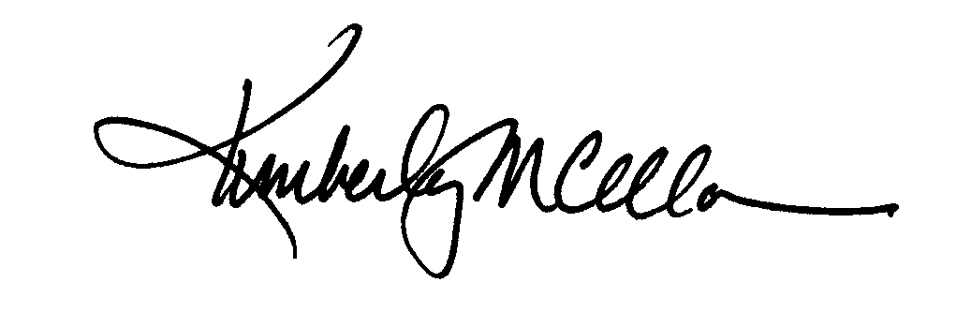

Kimberly M. Cella
Executive Director

Attachment
Building Ridership on Transit
Federal Aid No.: | IL CMAQ 2022
Location: | St. Louis Region
Proposed Improvement: | Building Ridership on Transit
Length: | December 20 2024
Approximate Construction Cost: | N/A
DBE Goal Determination | 0%
Consultant Services Required: | Citizens for Modern Transit (“CMT”) and the St. Clair County Transit District are seeking a graphic design consultant to assist CMT with the campaign for expansion of CMT’s Ten Toe Express education and walking program to promote ridership on the transit system. The goal will be to build participation in the program thus building ridership on the system and knowledge of the system.  Work products will include a Ten Toe tagline, a tri-fold brochure, program poster, two versions of a transit ad, two print advertisements tweaked to various sizes, billboard and web graphics.  CMT will need all these files in pdf, png, and jpeg formats no later than December 20, 2024. Other file types may be needed for printers as well. CMT will provide copy.
Other Comments:
Contact: | Kimberly Cella  Citizens for Modern Transit  701 Market, Ste. 275, St. Louis, MO 63101  kcella@cmt-stl.org/www.cmt-stl.org
Deadline: | 4 p.m, November 1, 2024
Submit
Proposal should not exceed 4 pages total. A page is defined as 8-1/2 by 11 inches and printed on one side. 2 copies of the proposal should be received at the address and by the time specified. Also, an email copy must be received by deadline as well.

Citizens for Modern Transit
701 Market, Ste. 275, St. Louis, MO 63101 www.cmt-stl.org 314.231.7272
The following criteria will be the basis for selection.
All proposals submitted in response to a CMT request for proposal (RFP) will initially be evaluated using the following criteria (each weighted equally):
- Qualifications of person/firm conducting the work
- Proposal Quality
- Product samples – samples provided and/or on firm website need to be relevant to work being asked to be completed.
Once the proposals are narrowed down to the top candidates using these criteria, the final selection will be determined with consideration to price and the above criteria. The proposal providing the best value to the project will be selected.
CMT will award the work to the responsible firm whose proposal is most advantageous to the project, with price and other factors considered. CMT reserves the right to reject any proposals deemed non-responsive to the RFP. CMT reserves the right to reject all proposals if the competitive process is not met and may reissue the RFP with or without changes.

Scope of Services
Citizens for Modern Transit (“CMT”) is seeking a graphic design consultant to assist CMT with the campaign for CMT’s Ten Toe Express Program to promote ridership on the transit system. The goal will be to provide current and potential riders with information on making transit easier to use.
Work products will include:
- New tagline
- Tri-fold registration brochure
- One program poster
- Two versions of transit ads
- Billboard
- Two print ads, tweaked to various sizes
- Web graphics

CMT will need all these files in pdf, png, and jpeg formats. Other file types may be needed for printers as well. CMT will provide copy. All products will need to be completed by December 20, 2024.
A detailed budget breakdown for each task/item listed above will need to be included with the proposal.
CMT encourages disadvantaged, small, women-owned, and/or minority business participation.

